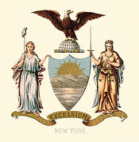 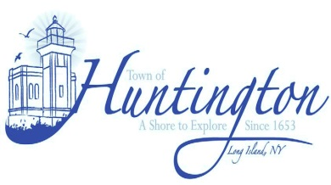

**Governor Andrew M. Cuomo**

**NY State Senator Carl L. Marcellino**

**NY State Assemblyman Chad A. Lupinacci**

**and**

**Huntington Councilwoman Tracey A. Edwards**

**Invite you to participate in:**

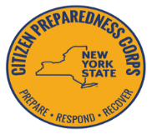

**New York State Citizen Preparedness Corps Training Program**

**Monday**

**September 18th, 2017**

**7:00 p.m.**

**Huntington Town Hall**

**The Presentation will be given by:**

* **The Governor’s Office**
* **Department of Homeland Security**
* **The National Guard**
* **NY State Fire and Police**
* **Suffolk County Fire and Rescue Emergency Services**

**All participants must register in advance at**

**[www.prepare.ny.gov](http://www.prepare.ny.gov/)**

**A free NYS disaster preparedness kit will be distributed per family that registers and attends in person**

**For Information please call 631-351-3317**

**Mark Cuthbertson Susan A. Berland Frank P. Petrone Eugene Cook Tracey A. Edwards**

**Councilman Councilwoman Supervisor Councilman Councilwoman**

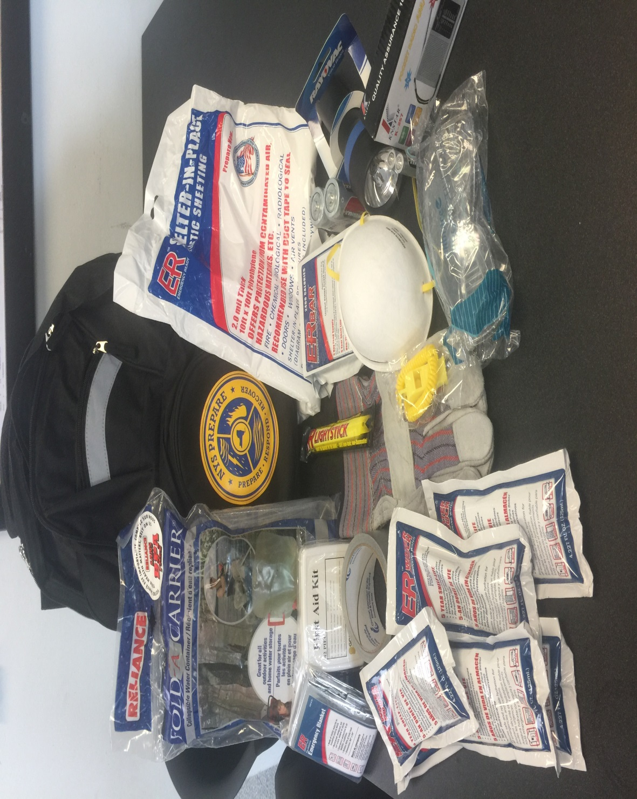

**The *FREE* Backpack includes the following**:

|  |  |
| --- | --- |
| * **Reflective Back pack** | * **Emergency blanket** |
| * **Transistor Radio** | * **Flashlight** |
| **with batteries** | **with batteries** |
| * **Light stick** | * **Duct Tape** |
| * **Water** | * **Protective Mask** |
| * **Freeze dried food** | * **Protective Glasses** |
| * **First Aid kit** | * **Emergency Whistle** * **Protective Gloves** |
| * **Shelter in Place: to protect from contaminated air hazardous materials etc** | * **Fold a Carrier: Collapsible Water Container holds 2.5 gallons of water** |
|  |  |

